- Instance Created in AWS – EC2

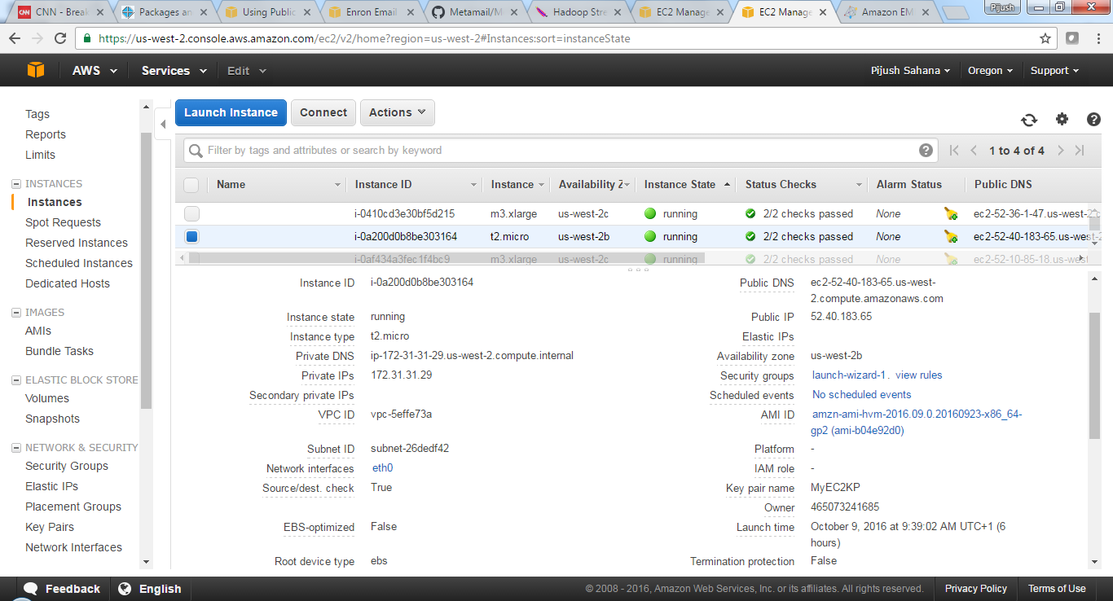

- New EBS Volume created with snapshot ID for Enron Email Data and Volume is attached to EC2 instance in AWS
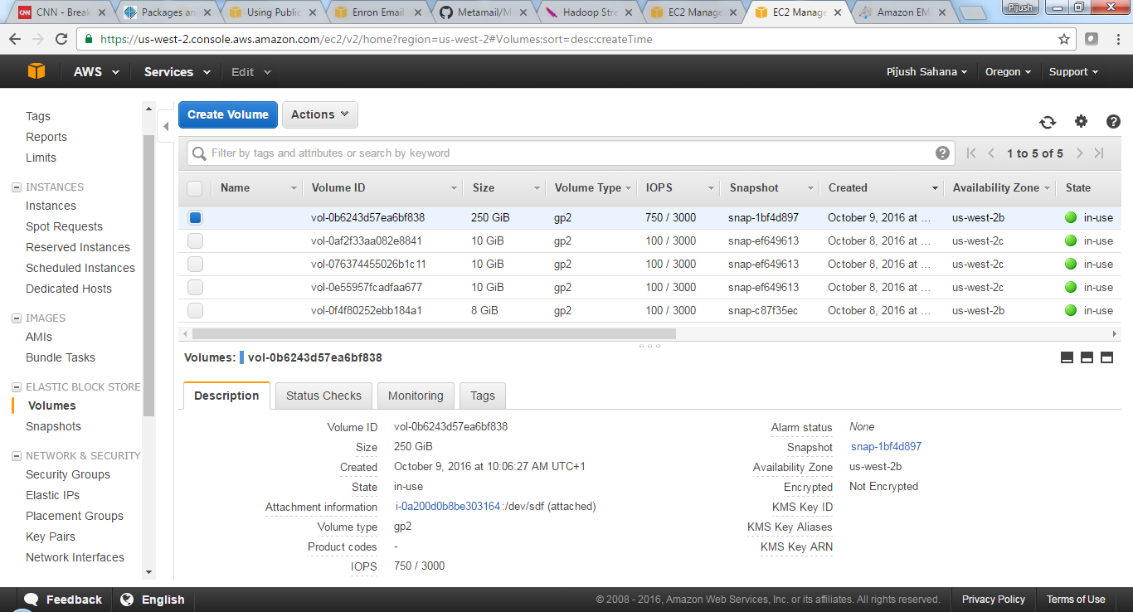

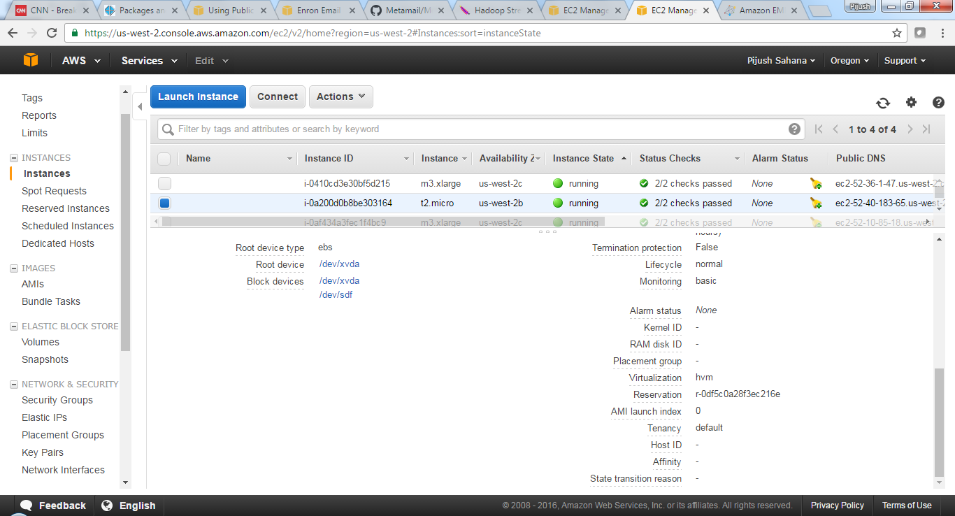

- EC2 instance is launched via login through Putty Command “lsblk” executed to show the devices
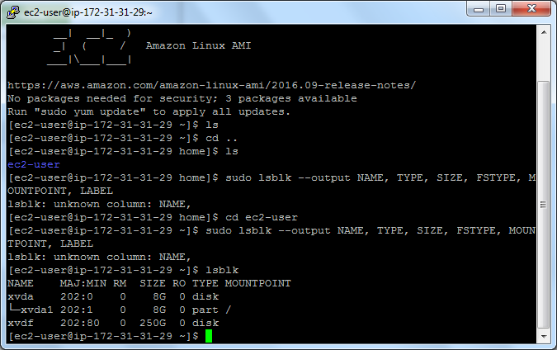
- File system already exists for /dev/xvda1 as seen below . The EBS volume has data in it as expected–
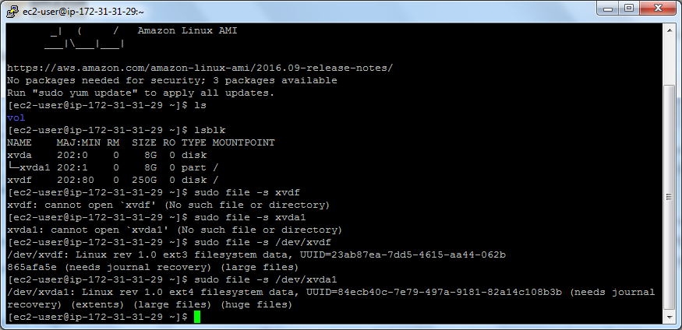
- Folder “mnt” created and device is mounted on mountpoint. Verified with command “df –h” as seen below

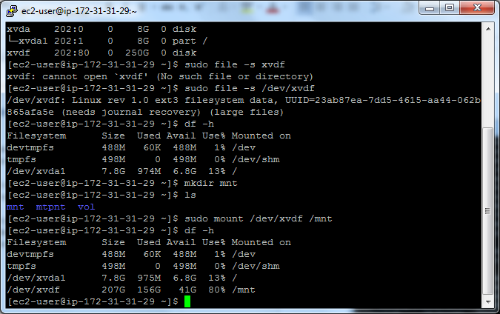

- I attempted to view the sample file format or get a sample in the local system using tools like FileZilla. However, I could not view the actual format in AWS EBS volume due to format issues. I got a sample of the Enron Email data from another source (in Kaggle). The file format worked on is shown below
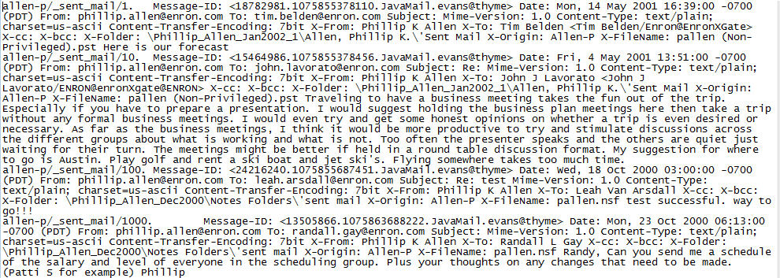
- Map-Reduce programs written in Java to extract the required information from the file. (Uploaded in Github)
- Sample output on sample data from Hadoop cluster shown below
a. Average number of words in e-mail text
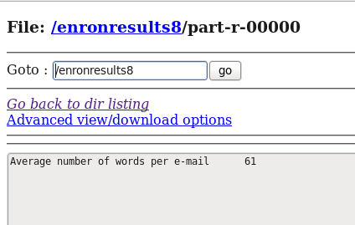

b. Number of times Recipients have been sent e-mails
